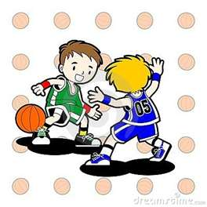






I agree to let my child participate in TNT SPORTS. I understand that there are certain risks of injury in the participation of this sport and I am willing to assume these risks. I confirm that my child is capable of participating in tennis and that he/she is in good physical condition. In addition to giving full consent to my child’s participation, I waive, release and hold harmless TNT SPORTS, it’s officers, coaches and representatives for any injury that may be suffered by my child. I grant permission for my child to receive emergency medical treatment.

I ___________________________________Agree.

Parent Name_________________________________Phone#______________________Cell#______________________

Student Name________________________________________Grade____________Teacher_______________________Attends After Care Y N

Student Name________________________________________Grade____________Teacher_______________________Attends After Care Y N

E-Mail___________________________________________ Amount Enclosed____________________Check#_____________(Payable TNT Sports)

* All Session must be paid in full at time of registration*

Who’s Eligible : Grades K-5 (Introduction To Our Sports Classes)

Where: Applegate

When: Wednesday, September 13th

Time: 3:15-4:45pm

Cost: $25 Per Child ($5.00 goes back to your PTO!)

SNEAKERS ARE REQUIRED!!!

Email: Susan O’Connor @ oconnorclan@optonline.net or Call (732) 995-2144

Sponsored By Applegate PTO Forms Due By: 9/12/17 99/12/17September12th

- Hand eye coordination

- Teamwork

- Throwing & Catching

- Body Control

- Positive Exercise

- Exciting Way to Introduce Tennis

- Hand-Eye Coordination

- Gross Motor Skills

- Groundstrokes, Volley and Serves

- Promotes Self-Esteem

- Passing Skills

- Dribbling Skills

- Shooting Skills ( Learning To Shoot)

- Footwork Skills

- Ball Handling

Come and enjoy our Introductory class that “mixes” up some of TNT Sports popular selections! We provide the equipment! We provide the coaches! Let’s have some FUN!!! Each sport station will have 25 mins of solid activity! *** Bring Your Own Water!!!***

